# Output

Input: We pick an agent of our choice in the Play With drop down menu. Here we have chosen Agent Gold. After that, we let the agent pick the suit before we pick a suit for ourselves. To do that, select “Let AI Pick Suit first” option in the Your Suit dropdown menu.  
After that, pick “Pick Suit” option in the Agents Suit dropdown menu. After clicking the Play Turn button, the picked suit by the agent is reflected in the Agents Suit dropdown.

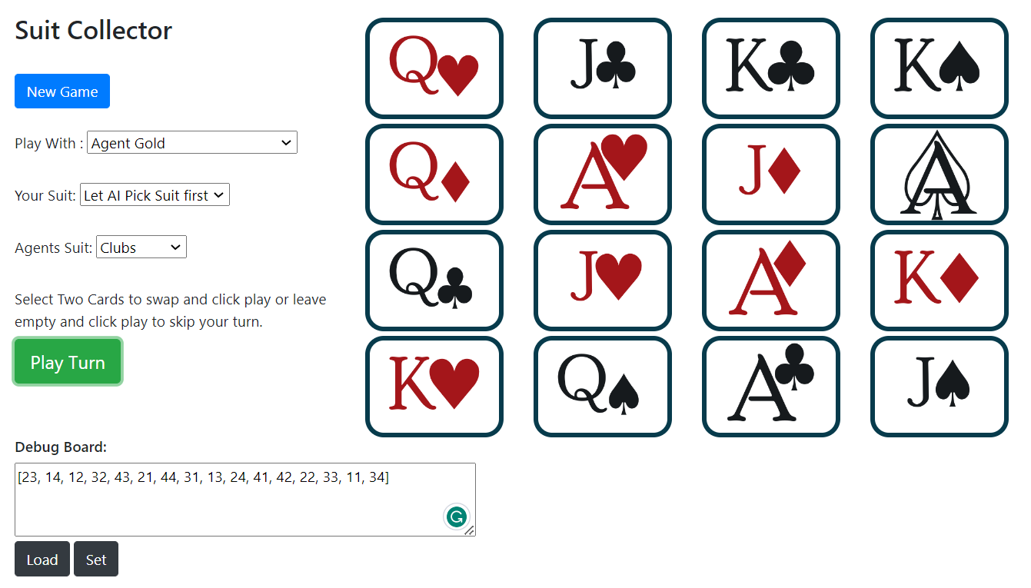

After that, the user must pick a suit. Here we pick Spades.  
After picking the suit for the user from Your Suit dropdown menu, click on the Play Turn button. This will prompt the agent to make the first move. Here the agent chose to swap Ace of Hearts with Queen of Clubs. The cards swapped by the agent are highlighted in the green border.

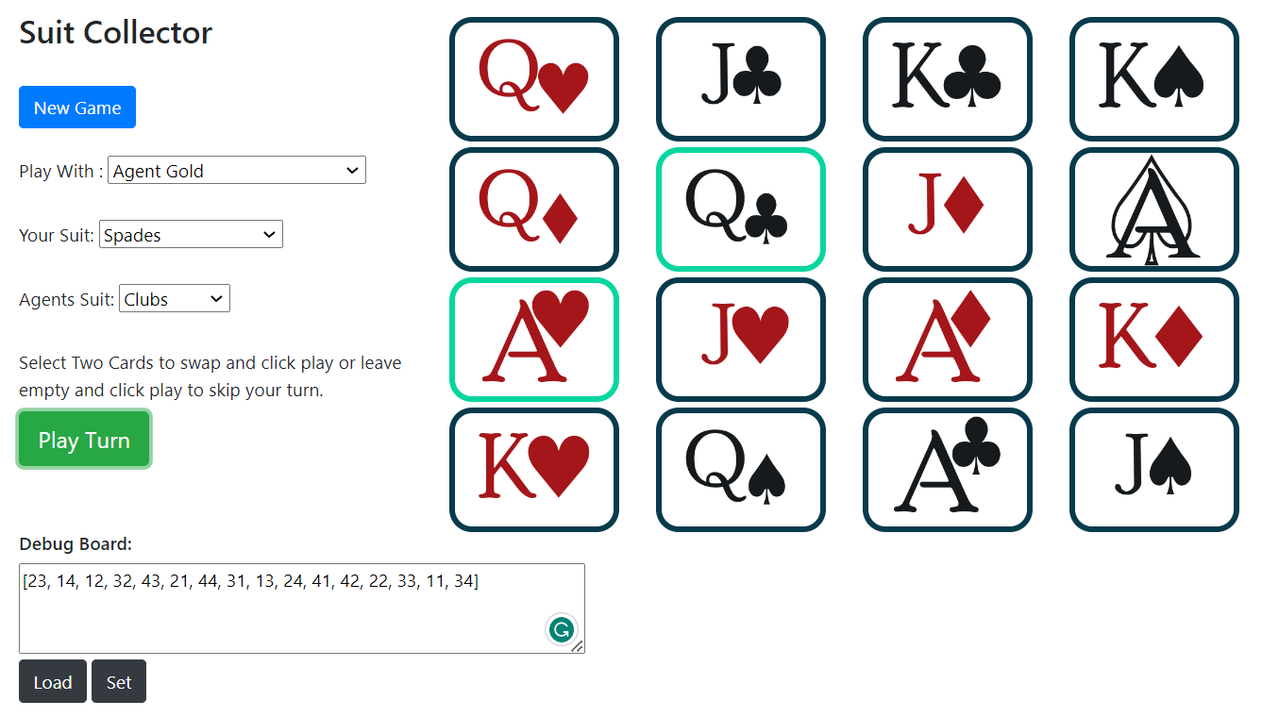

It is our turn to play now. We click on two cards (here those are Queen of Spades and Ace of Diamonds). The user’s cards are highlighted in the red border. We must click on these two cards and then the Play Turn button.

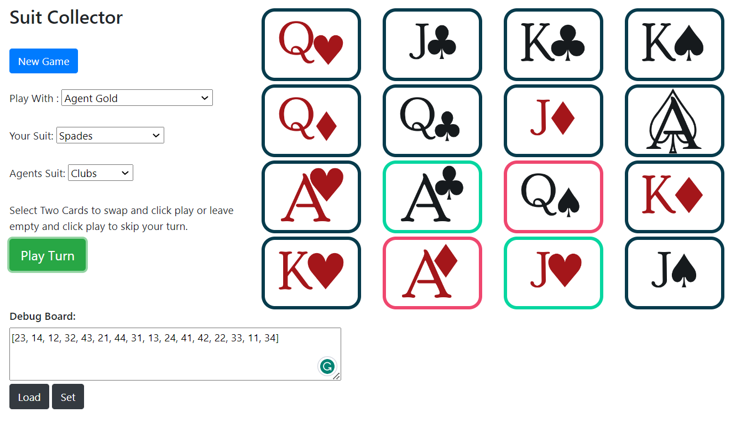

After that, the cards will be swapped and then the agent will play its move.

The game will go on till either the agent wins or the user wins. Here in our case, we win!!!

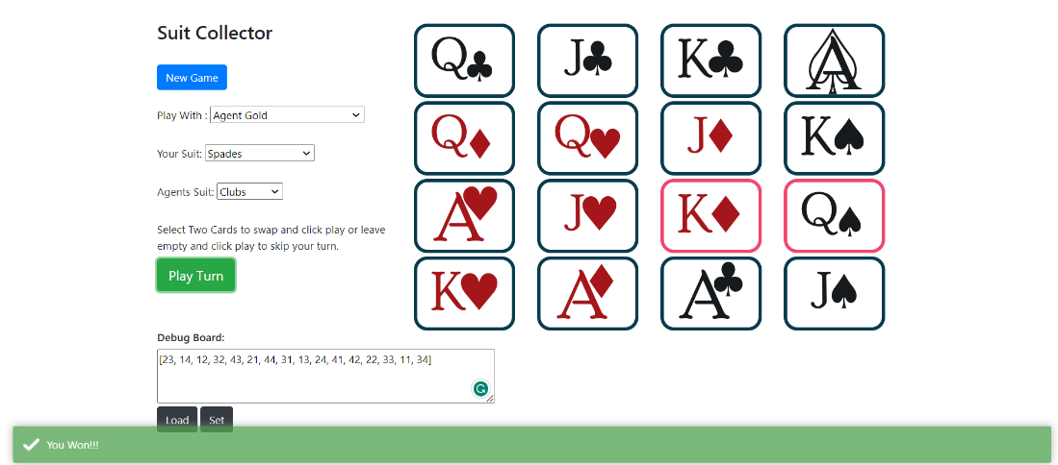

If we try to make a move after the game is over, we get another alert in the blue box saying the game has already ended.

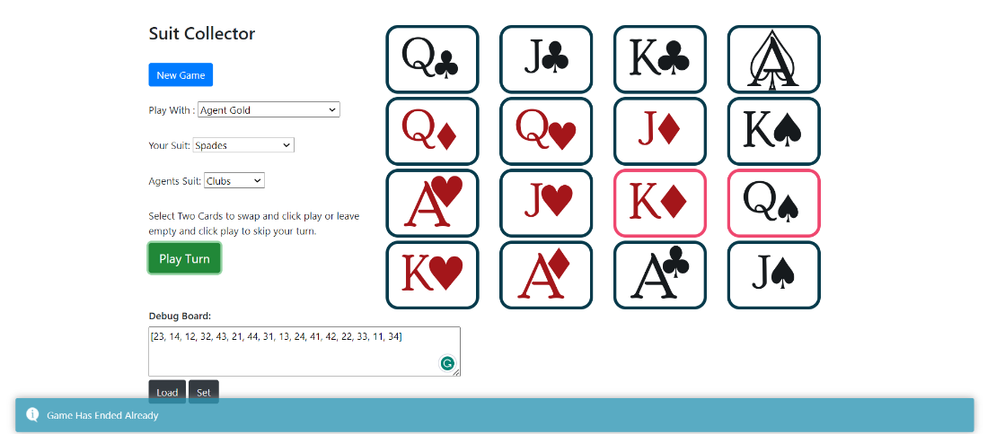

Here are a few different outputs we have generated by playing with different agents, selecting different cards, and obtaining the outputs.

1. Played with Agent Rock and won against it.



1. We played with Agent Iron and won against it.



1. Played against Agent Iron and when it plays against a beginner it makes them lose as well, this shows our model’s integrity.



1. Played against agent Gold and won.



1. Played against agent Diamond-1 and won.

Diamond-1.



1. Played against agent Diamond-2 and won.

Diamond-2.



1. As the model is trained further, our latest agent has made some good moves which made us lose when playing against it. As it is now familiar with blocking user’s moves.

Diamond-2.

